1. We will create queue with the help of RabbitMQ Management (User Friendly Interface).
2. Without having exchange, we can have queue and publish the message to queues and get the messages from the queues into the consumer.
3. Let’s concentrate on the queue. Let’s see the followings:
   1. How to create queue.
   2. How to publish the messages from the publishers to the queue.
   3. How to consume the messages from the queue.

**NOTE**: There will be no exchange.

1. 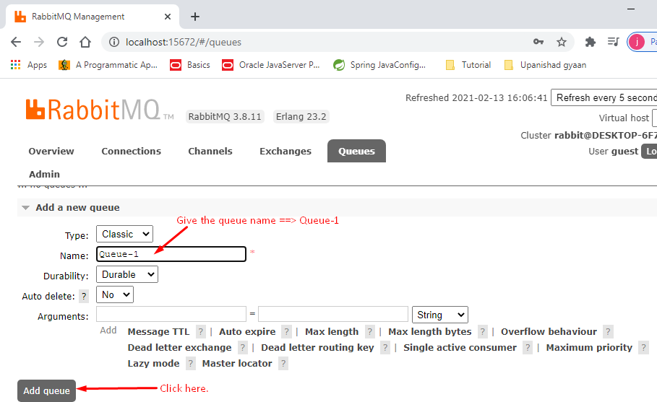
2. 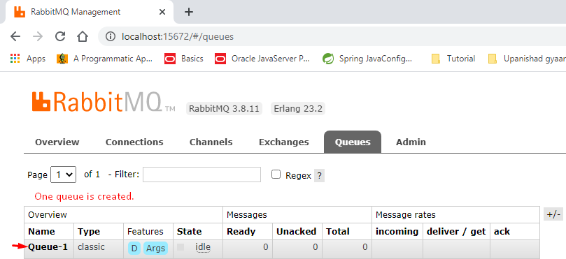
3. 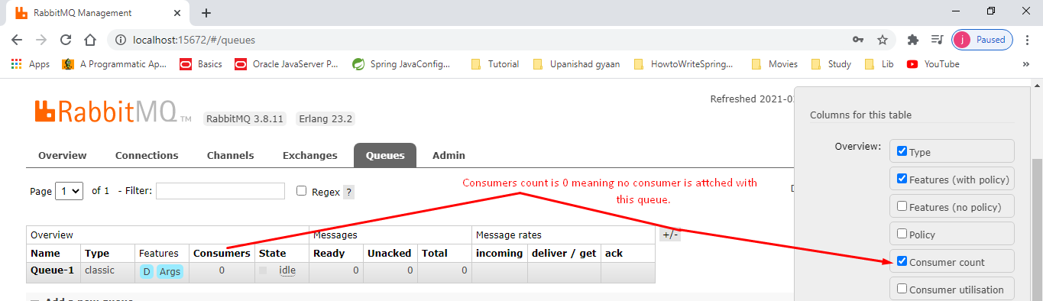
4. In the next lecture, we will publish a message to this queue.